Bash Scripting: Functions, Arrays, Strings, Flags, Special Variables, and Loops
These are important Bash scripting concepts used in Linux administration, automation, and DevOps.

1. Functions in Bash
A function is a reusable block of commands. Functions help avoid repeating the same code.

Syntax
function_name() {
commands
}

Example
#!/bin/bash

greeting() {
echo "Hello, Welcome to Bash Scripting"
}

greeting

Output
Hello, Welcome to Bash Scripting
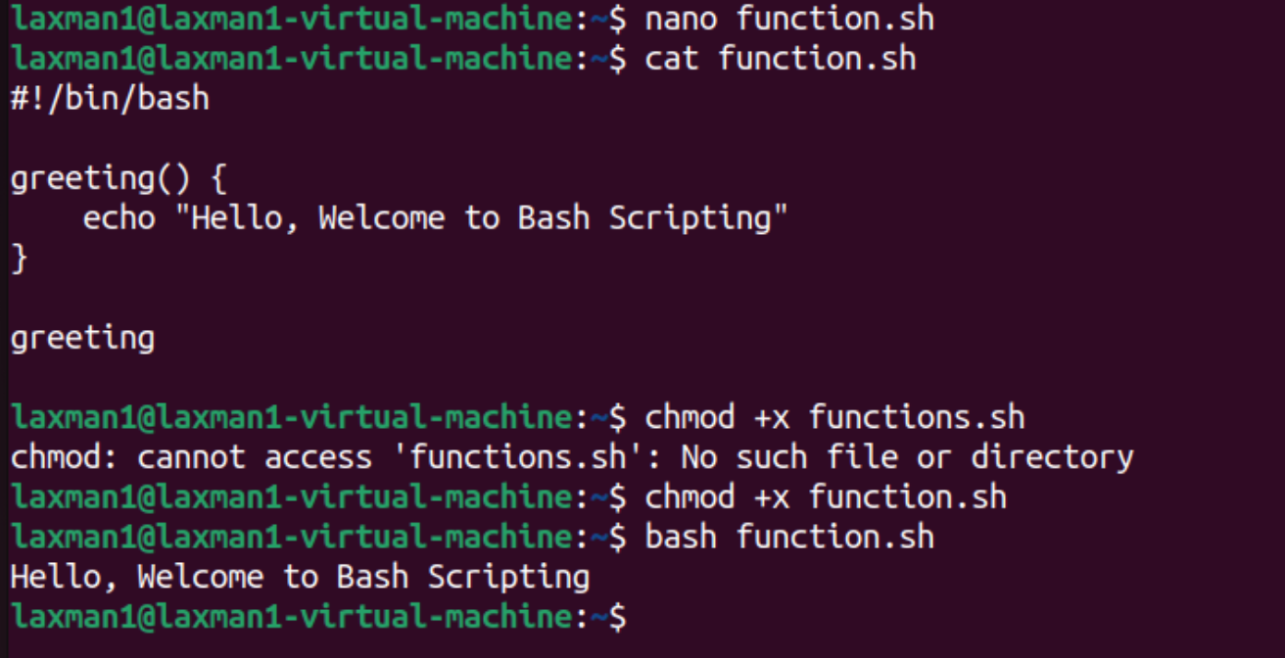

Function with Arguments
#!/bin/bash

greeting() {
echo "Hello $1"
}

greeting "Lakshman"
Output:
Hello Lakshman
Here, $1 represents the first argument passed to the function. 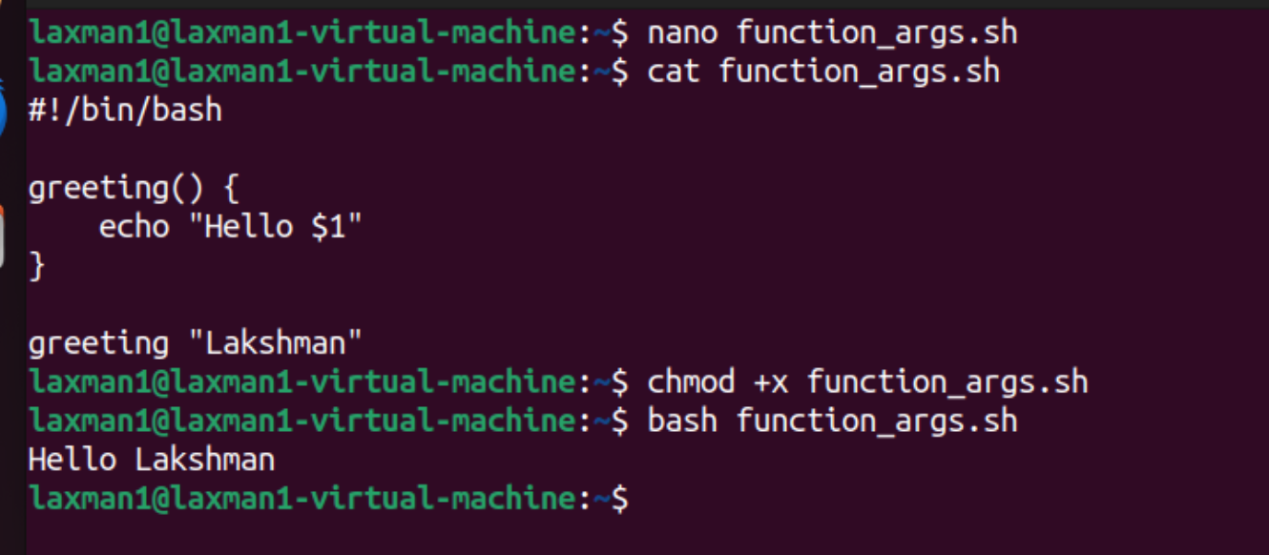

Function with Two Arguments
#!/bin/bash

add_numbers() {
sum=$(( $1 + $2 ))
echo "Sum = $sum"
}

add_numbers 10 20
Output:
Sum = 30 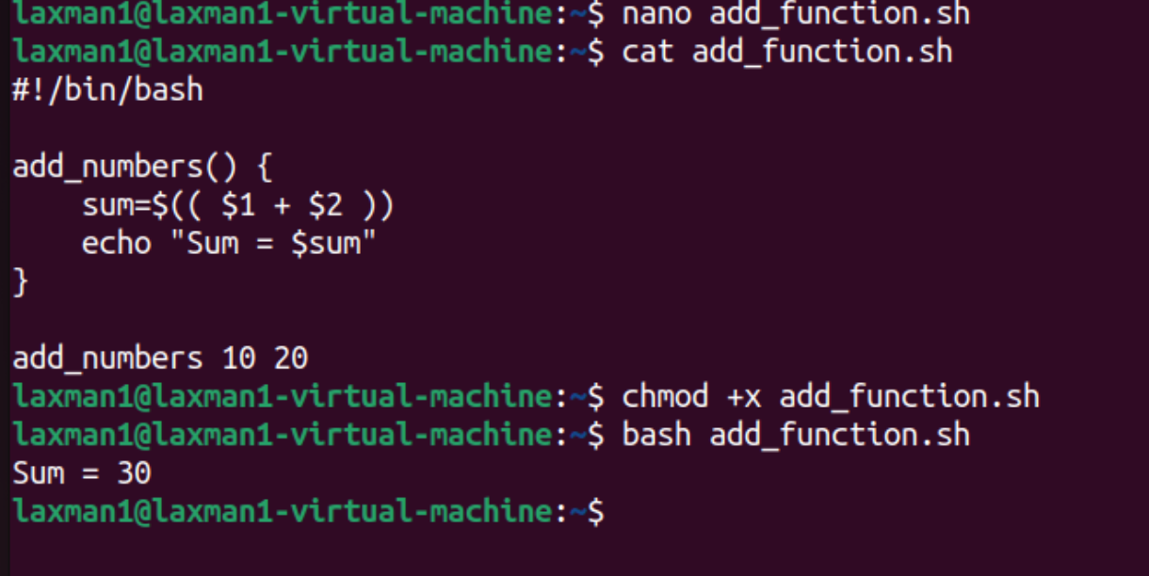

2. Arrays in Bash
An array stores multiple values in a single variable.

Creating an Array
#!/bin/bash

names=("Lakshman" "Kumar" "Pinninti")

echo "First name: ${names[0]}"
echo "Second name: ${names[1]}"
echo "Third name: ${names[2]}"
Output:
First name: Lakshman
Second name: Kumar
Third name: Pinninti
Bash array indexes start from 0.

Display All Elements
echo "${names[@]}"
Output:
Lakshman Kumar Pinninti

Number of Elements
echo "Number of names: ${#names[@]}"
Output:
Number of names: 3

Loop Through an Array
#!/bin/bash

names=("Lakshman" "Kumar" "Pinninti")

for name in "${names[@]}"
do
echo "Name: $name"
done
Output:
Name: Lakshman
Name: Kumar
Name: Pinninti 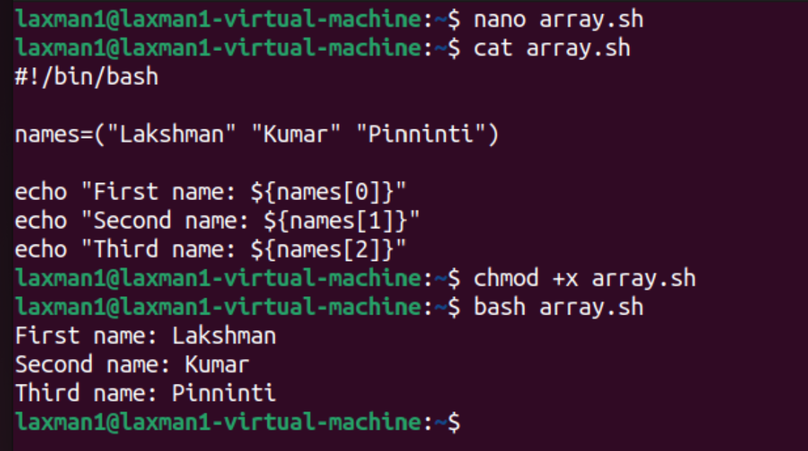
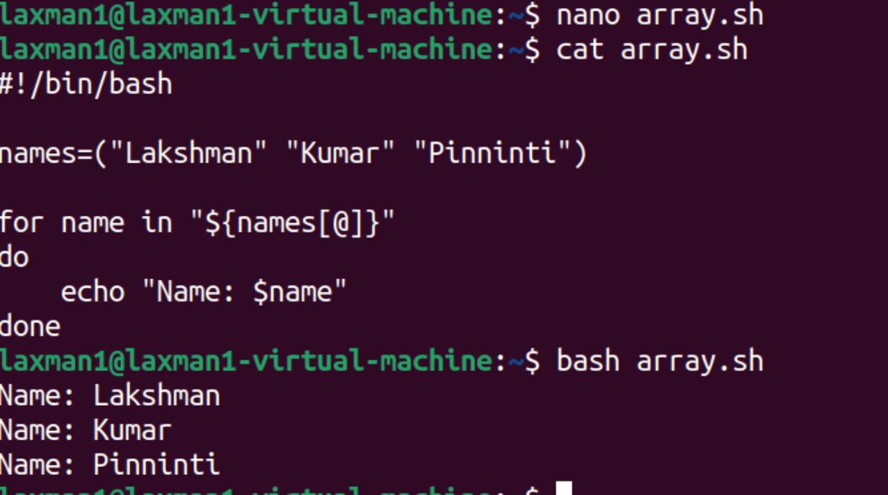

3. Strings in Bash
A string is a sequence of characters.

Creating String Variables
#!/bin/bash

first_name="Lakshman"
last_name="Kumar"

full_name="$first_name $last_name"

echo "Full Name: $full_name"
Output:
Full Name: Lakshman Kumar

String Length
Use ${#variable} to find the length.
#!/bin/bash

name="Lakshman"

echo "Name: $name"
echo "Length: ${#name}"
Output:
Name: Lakshman
Length: 8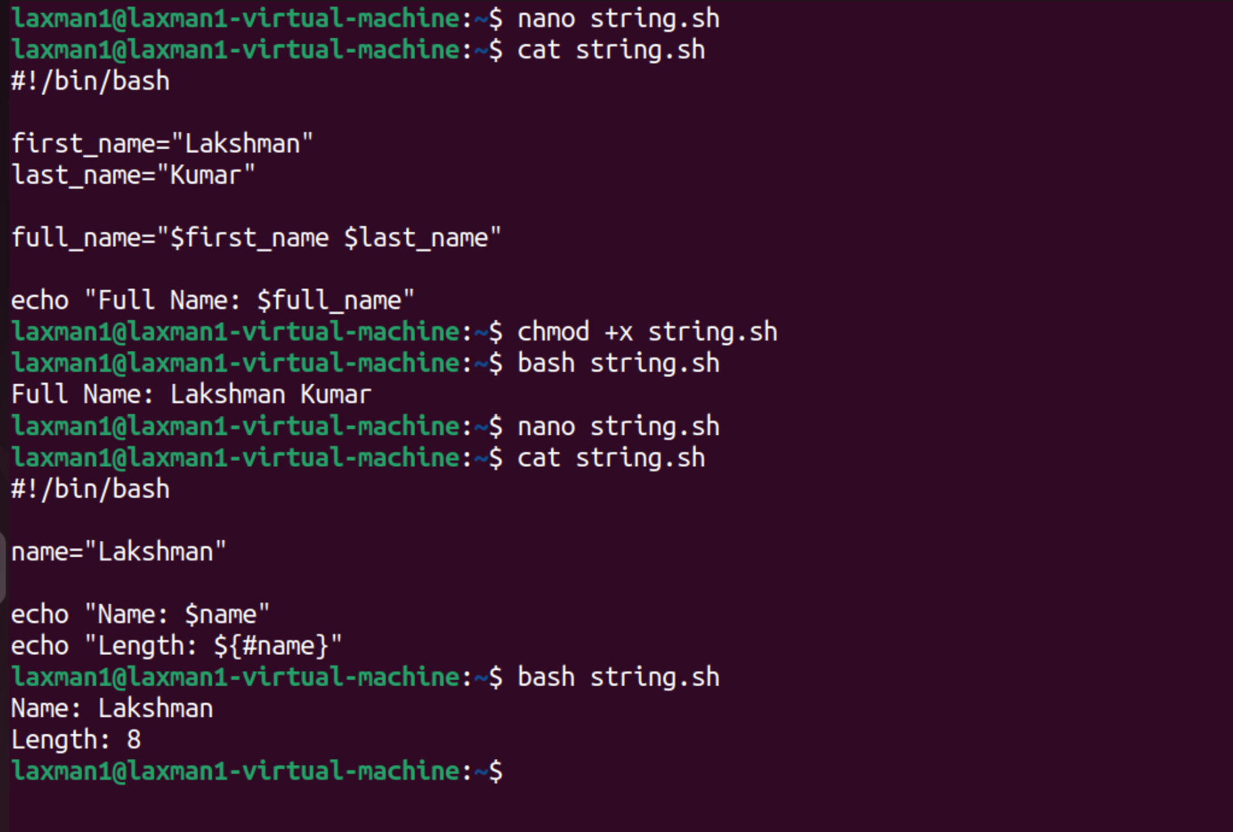

String Comparison
#!/bin/bash

name="Lakshman"

if [ "$name" = "Lakshman" ]
then
echo "Name matched"
else
echo "Name did not match"
fi
Output:
Name matched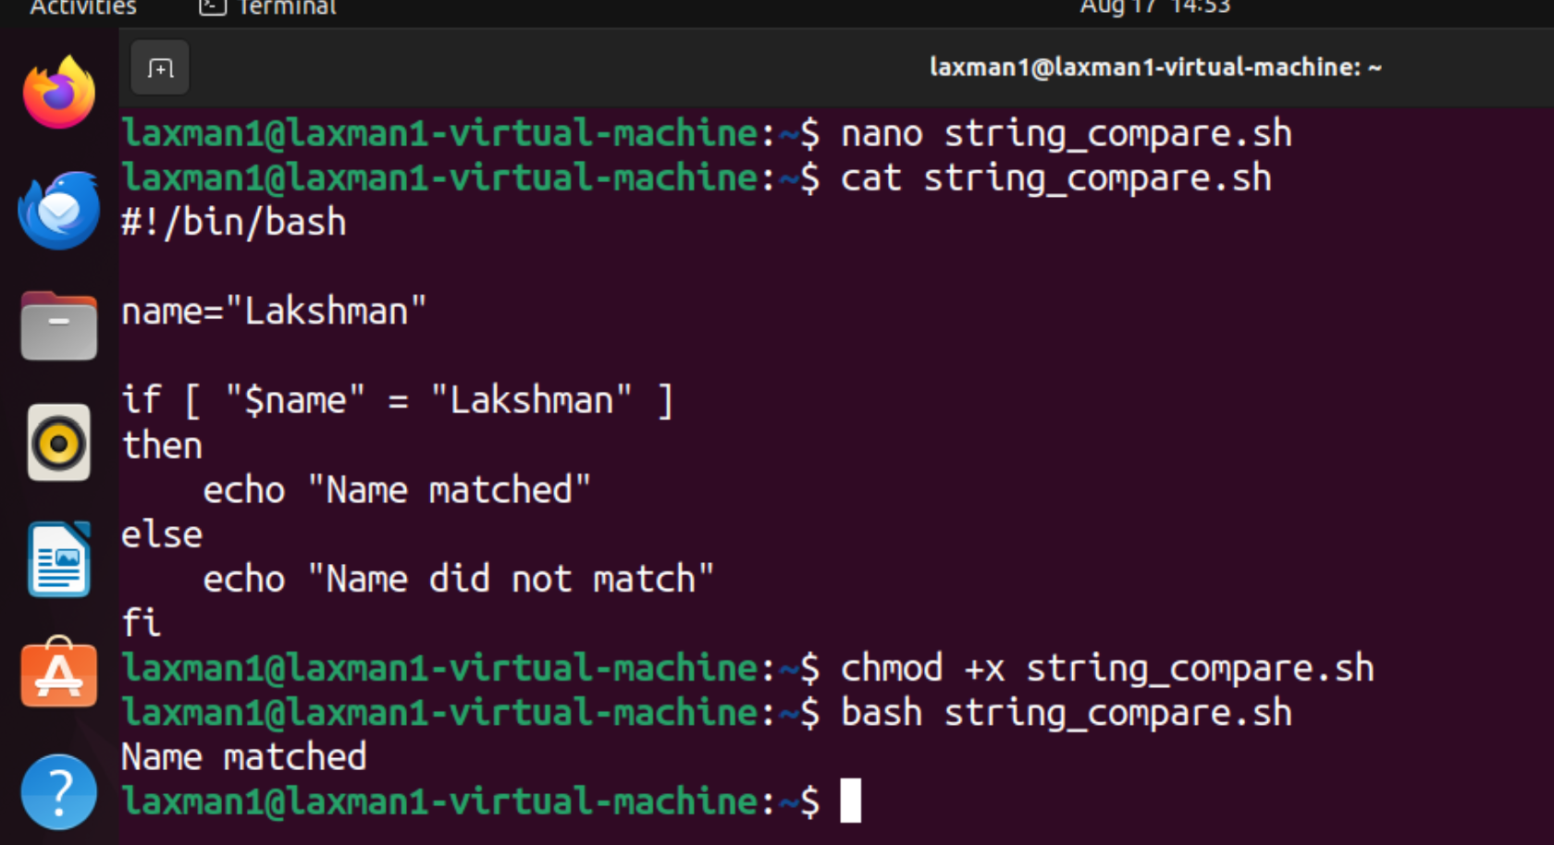

Check Empty String
#!/bin/bash

name=""

if [ -z "$name" ]
then
echo "String is empty"
else
echo "String is not empty"
fi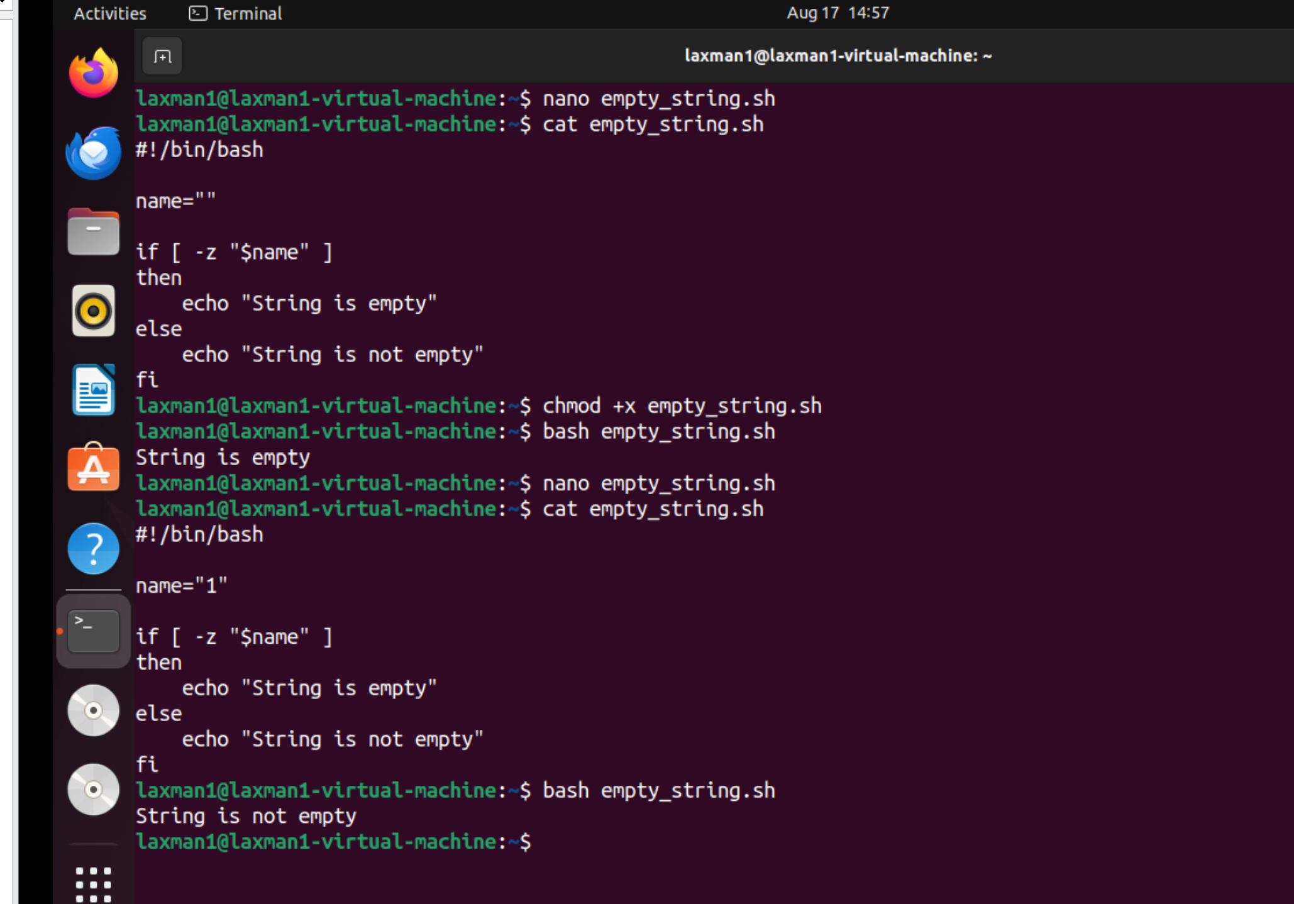

4. Flags in Bash
In Bash, flags are commonly used with commands and test conditions to check files, directories, permissions, and strings.

File and Directory Flags
Flag | Meaning
-f | Regular file exists
-d | Directory exists
-e | File or directory exists
-r | File is readable
-w | File is writable
-x | File is executable

Example: Check Directory
#!/bin/bash

DIR="/home/ec2-user/test"

if [ -d "$DIR" ]
then
echo "Directory exists"
else
echo "Directory does not exist"
fi 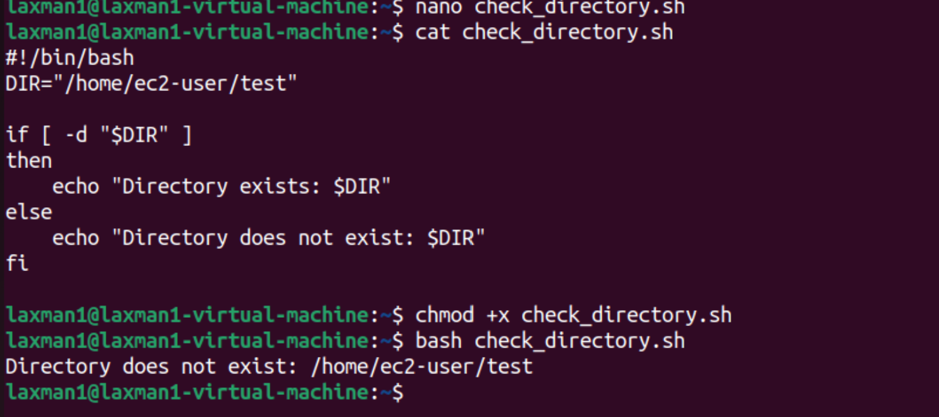

Example: Check File
#!/bin/bash

FILE="/home/ec2-user/test.txt"

if [ -f "$FILE" ]
then
echo "File exists"
else
echo "File does not exist"
fi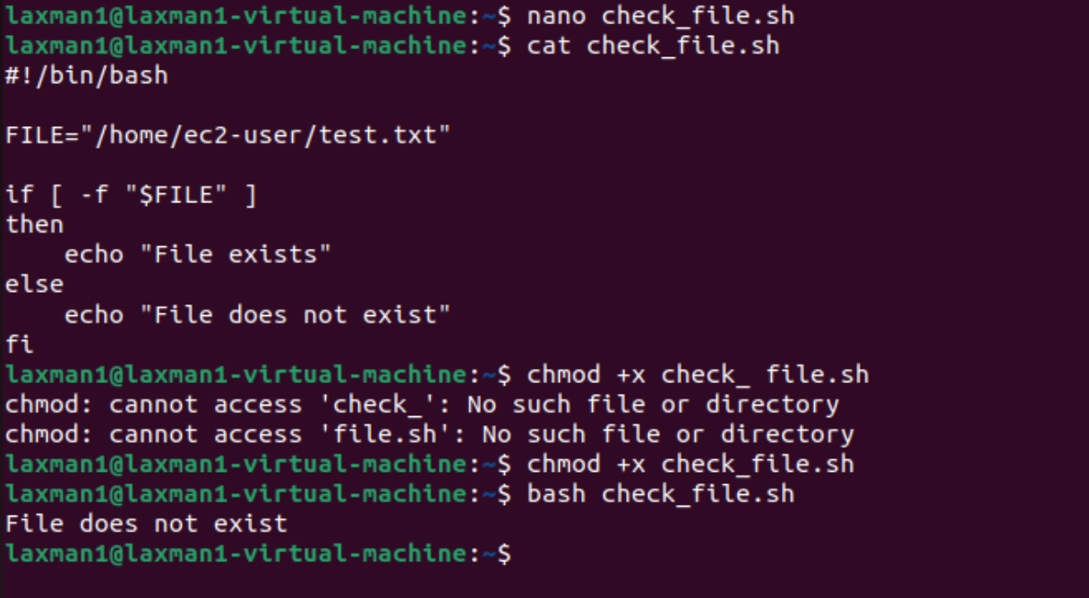

String Flags
Flag | Meaning
-z | String is empty
-n | String is not empty
Example:
#!/bin/bash

NAME="Lakshman"

if [ -n "$NAME" ]
then
echo "Name is not empty" 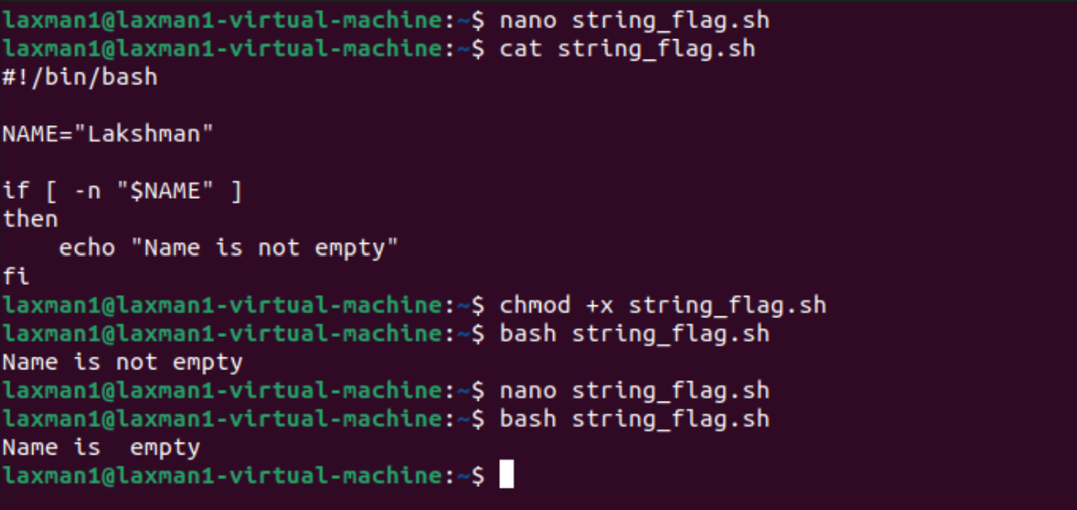
fi

5. Special Variables in Bash
Bash provides several predefined special variables.
Variable | Meaning
$0 | Script name
$1 | First argument
$2 | Second argument
$# | Number of arguments
$@ | All arguments
$* | All arguments
$? | Exit status of previous command
$$ | Current process ID
$! | Process ID of most recently executed background command

Example
#!/bin/bash

echo "Script name: $0"
echo "First argument: $1"
echo "Second argument: $2"
echo "Number of arguments: $#"
Execute:
./script.sh Linux Ubuntu
Output:
Script name: ./script.sh
First argument: Linux
Second argument: Ubuntu
Number of arguments: 2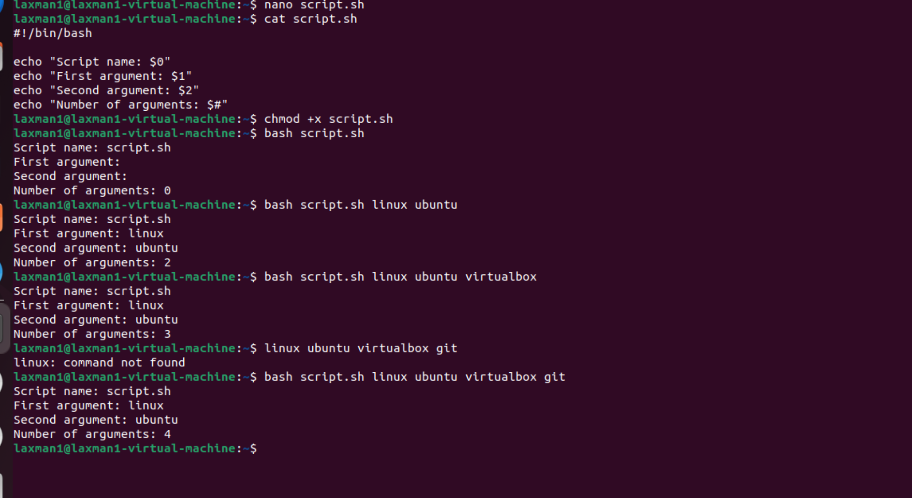

$? — Exit Status
#!/bin/bash

ls /home

echo "Exit status: $?"
Normally:
Exit status: 0
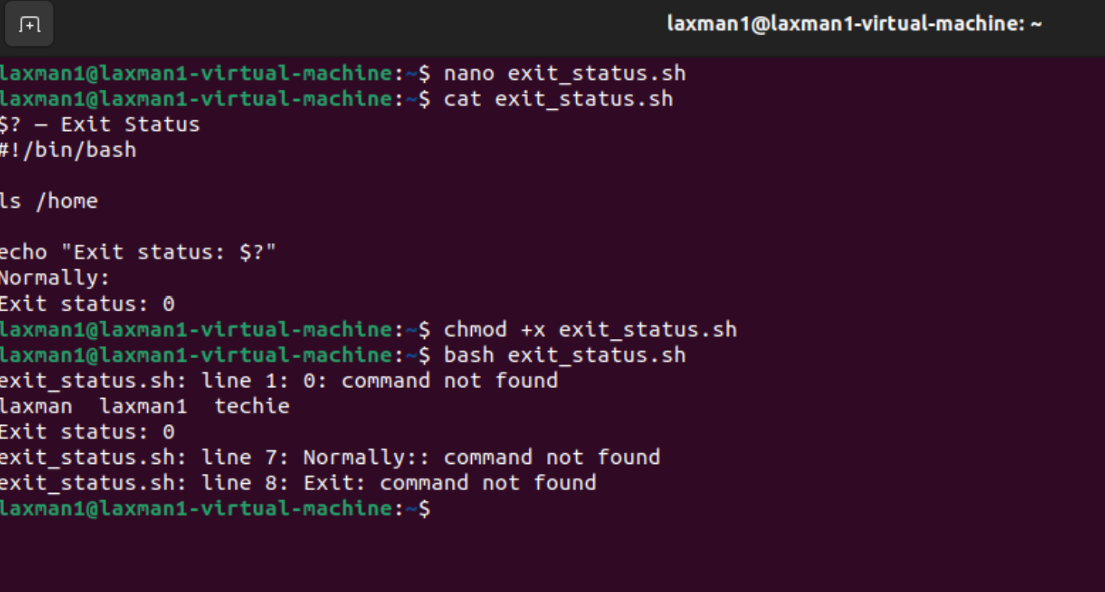
An exit status of 0 generally means the command succeeded; a non-zero value indicates an error or other unsuccessful status.

6. Loops in Bash
Loops allow you to execute commands repeatedly.
The main Bash loops are:
- for
- while
- until

6.1 For Loop
A for loop is commonly used to iterate through a list of values.
#!/bin/bash

for name in Techie Horizon Institute
do
echo "Name: $name"
done
Output:
Name: Techie
Name: Horizon
Name: Institute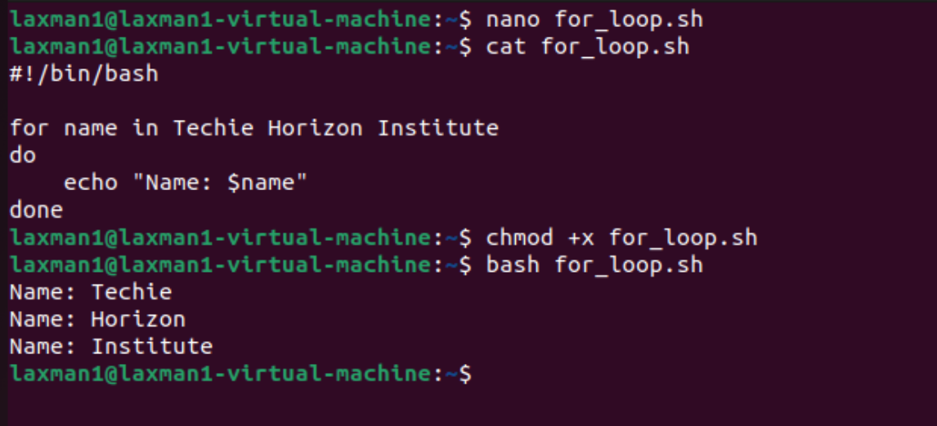

For Loop with Numbers
#!/bin/bash

for i in {1..5}
do
echo "Number: $i"
done
Output:
Number: 1
Number: 2
Number: 3
Number: 4
Number: 5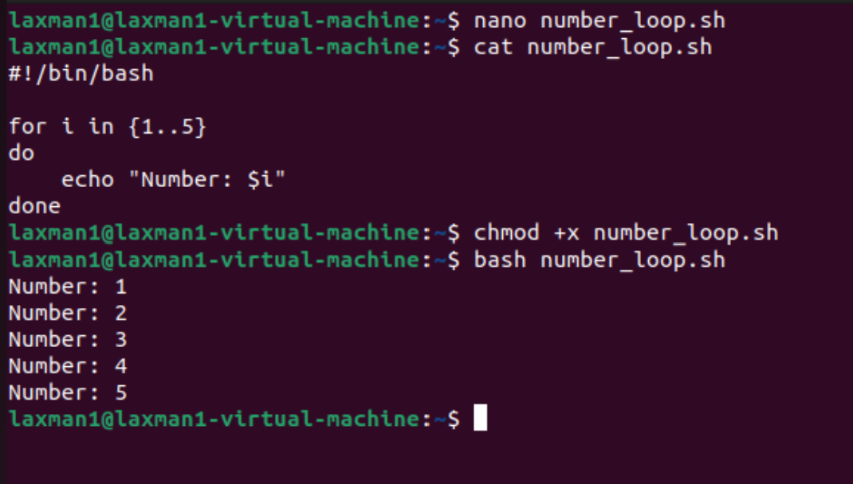

6.2 While Loop
A while loop continues as long as its condition is true.
#!/bin/bash

count=1

while [ $count -le 5 ]
do
echo "Count: $count"
((count++))
done
Output:
Count: 1
Count: 2
Count: 3
Count: 4
Count: 5 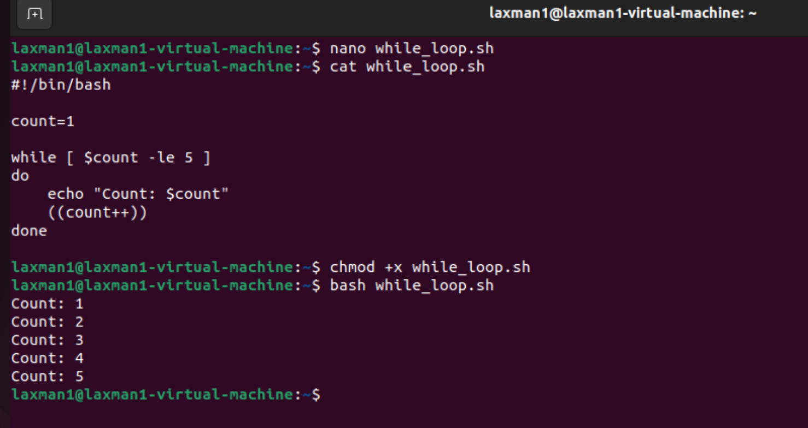

6.3 Until Loop
An until loop continues until its condition becomes true.
#!/bin/bash

count=1

until [ $count -gt 5 ]
do
echo "Count: $count"
((count++))
done
Output:
Count: 1
Count: 2
Count: 3
Count: 4
Count: 5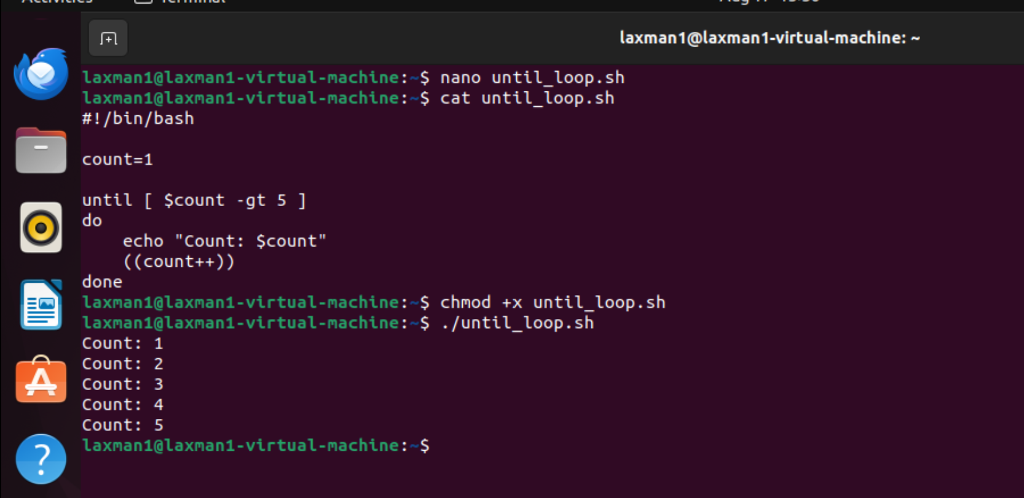

7. break Statement
break immediately exits a loop.
#!/bin/bash

for i in {1..10}
do
if [ $i -eq 5 ]
then
break
fi

echo "Number: $i"
done
Output:
Number: 1
Number: 2
Number: 3
Number: 4

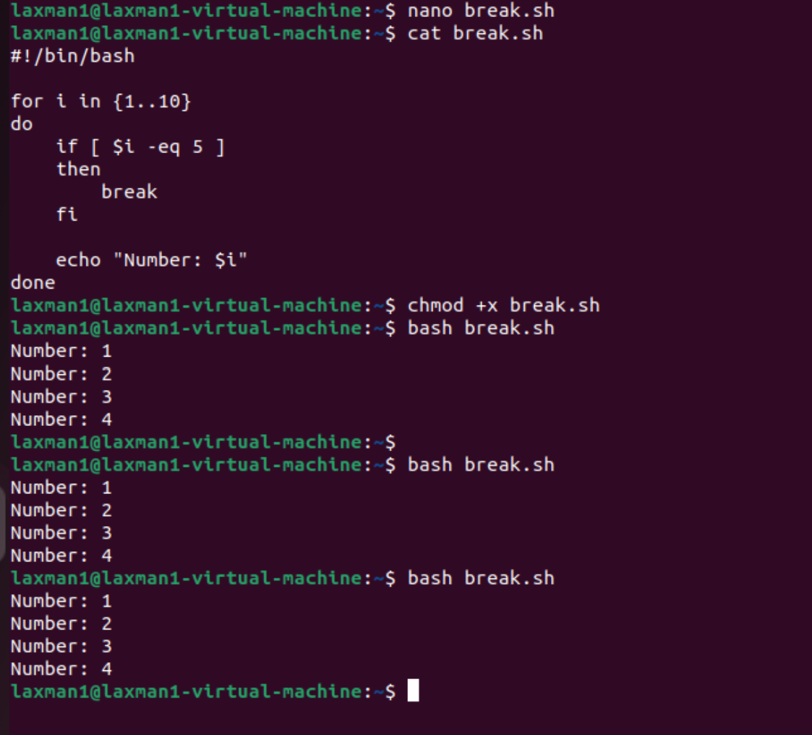

8. continue Statement
continue skips the current iteration and moves to the next iteration.
#!/bin/bash

for i in {1..5}
do
if [ $i -eq 3 ]
then
continue
fi

echo "Number: $i"
done
Output:
Number: 1
Number: 2
Number: 4
Number: 5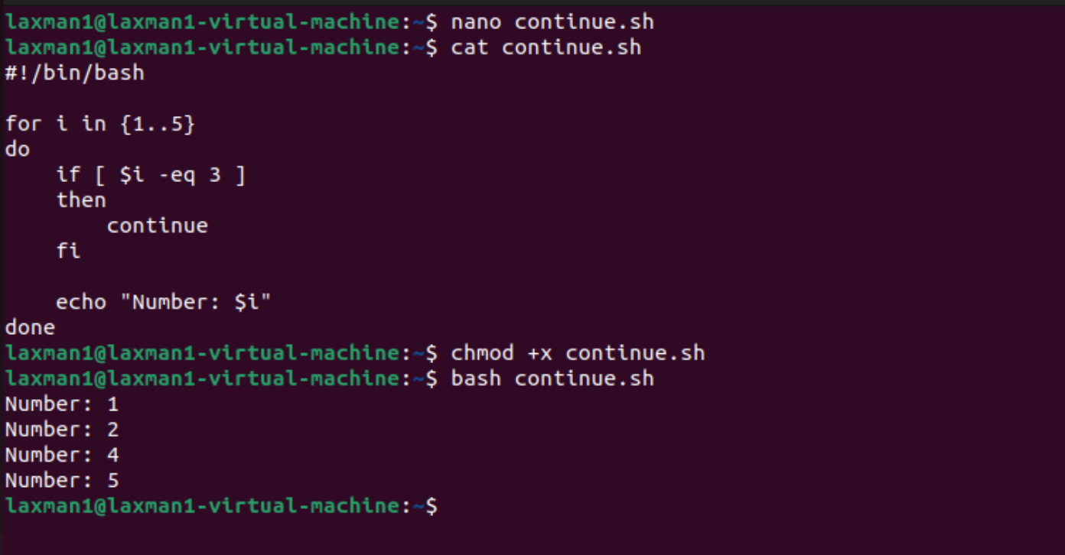

9. Practical Example Combining Functions, Arrays, and Loops
#!/bin/bash

names=("Lakshman" "Kumar" "Ravi")

show_names() {
for name in "${names[@]}"
do
echo "Name: $name"
done
}

show_names
Output:
Name: Lakshman
Name: Kumar
Name: Ravi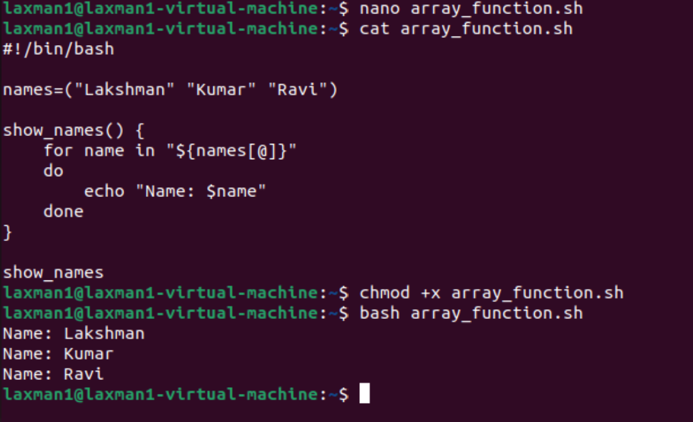
This example combines:
- Array → stores multiple names.
- Function → show_names.
- For loop → processes each array element.
- Variable → $name stores the current array element.

10. How to Execute Bash Scripts
Create a script:
nano script.sh
Give execute permission:
chmod +x script.sh
Run it:
./script.sh
Alternatively:
bash script.sh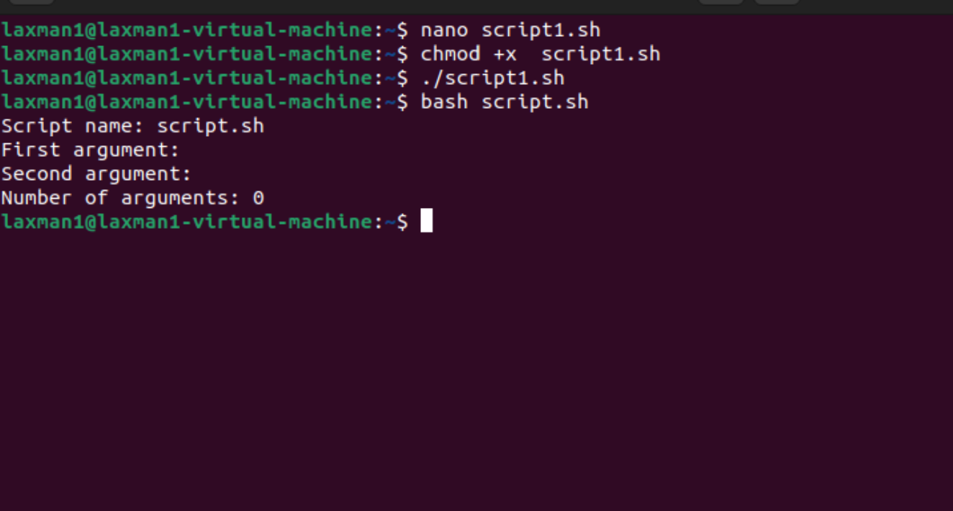

Quick Summary
Topic | Main Syntax/Example
Function | name() { commands; }
Array | arr=("one" "two")
String | name="Lakshman"
File flag | [ -f "$file" ]
Directory flag | [ -d "$dir" ]
First argument | $1
Number of arguments | $#
All arguments | $@
Exit status | $?
For loop | for x in list
While loop | while [ condition ]
Until loop | until [ condition ]
Exit loop | break
Skip iteration | continue
These concepts form a strong foundation for writing Bash automation scripts, Linux administration scripts, backup scripts, monitoring scripts, and DevOps automation.

